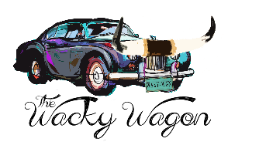
Hi darlin’! Thank you for allowing me to design your Wacky Wagon custom brand tee! This is going to be amazing, but first I need to understand what you envision your dream brand tee to be. Also, don’t forget to provide me with a picture of your brand or sketch it below – that’s kinda important!! >>> thewackywagon@gmail.com <<<
Shirt Style (Please check one)
__ T-Shirt Crew Neck ($39) ___ T-Shirt V Neck ($39)
*Reach out for other style options (prices and color options will vary)
Shirt Size (Please circle)
Adult - S M L XL 2XL 3XL
Youth - YXS YS YM YL YXL
Shirt Fit (For adults only)
Unisex/Relaxed Ladies/Fitted
Shirt Color (For adults only)
___ Black ___White ___Grey ___Teal ___Brown ___Red ___Purple ___Tan ___Pink ___Blue
___Yellow Other:__________________________
*Reach out for more color options
Brand Inlay (For youth only)
___Floral ___Leather ___Paisley ___Leopard ___Serape ____Polka Dot ___Western ____Aztec Other: ______________________________________________________
*Reach out for more inlay options
If you want to include your ranch name, please provide it below

Payment Information
CC________________________________ Exp___________________ CVC______________
Shipping Address: _______________________________________________________________
Paypal Me: ____________________________________

PLEASE SKETCH YOUR BRAND BELOW THIS LINE OR EMAIL A PICTURE WITH THIS FORM
______________________________________________________________________________

